Advanced Computer Networking and Security - 5800

Assignment -3

ARP Cache Poisoning Attack Lab

Name: SAI ROHIT JONNADA

ID :700723743

**Turning on the docker** 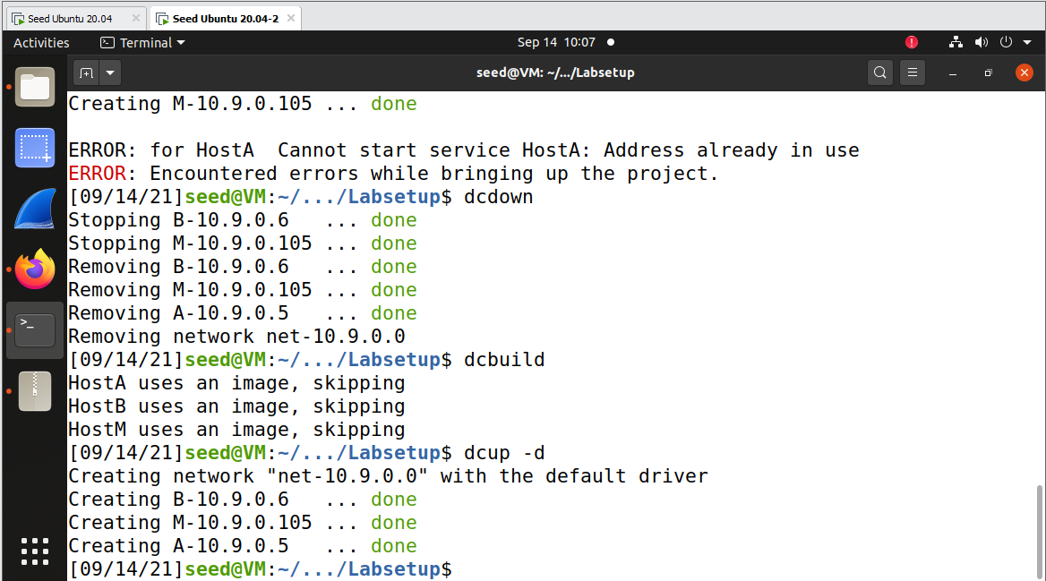

**Code For sending fake ip address from attacker to docker ip 10.9.0.5**

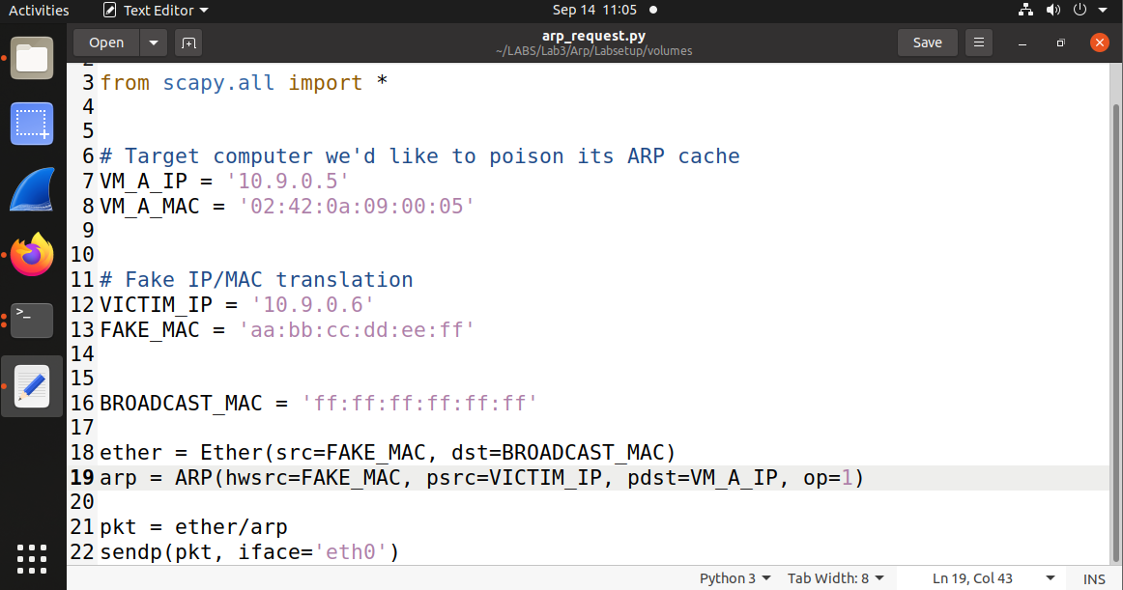

**Sending the arp request from attacker to docker ip 10.9.0.5**

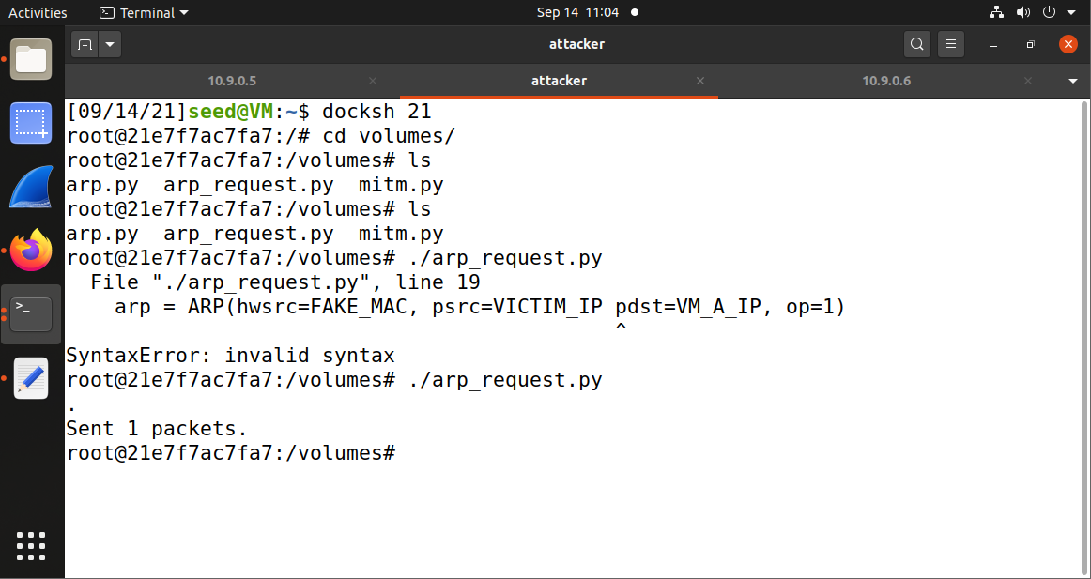

**Checking the arp in 10.9.0.5 and find the new ip address with fake mac address that we sent from attacker**

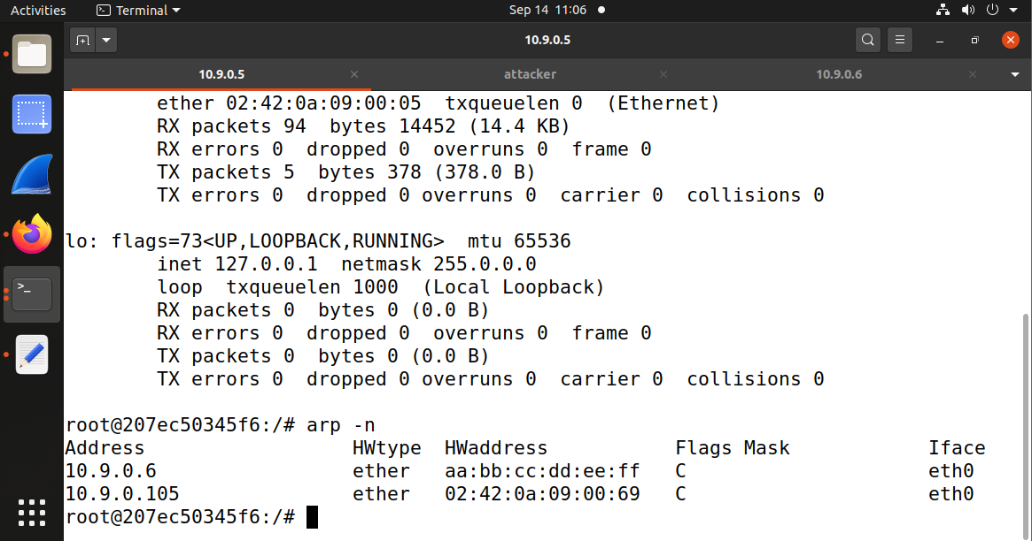

**Deleting the fake ip and mac address**

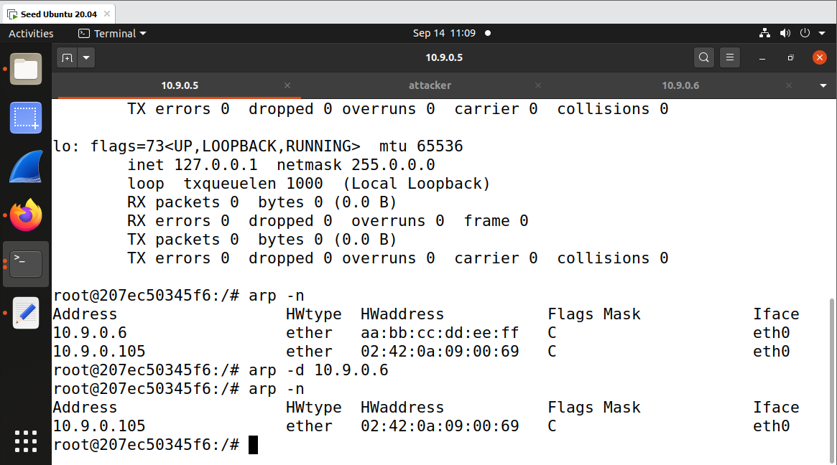

**Code for Arp Reply**

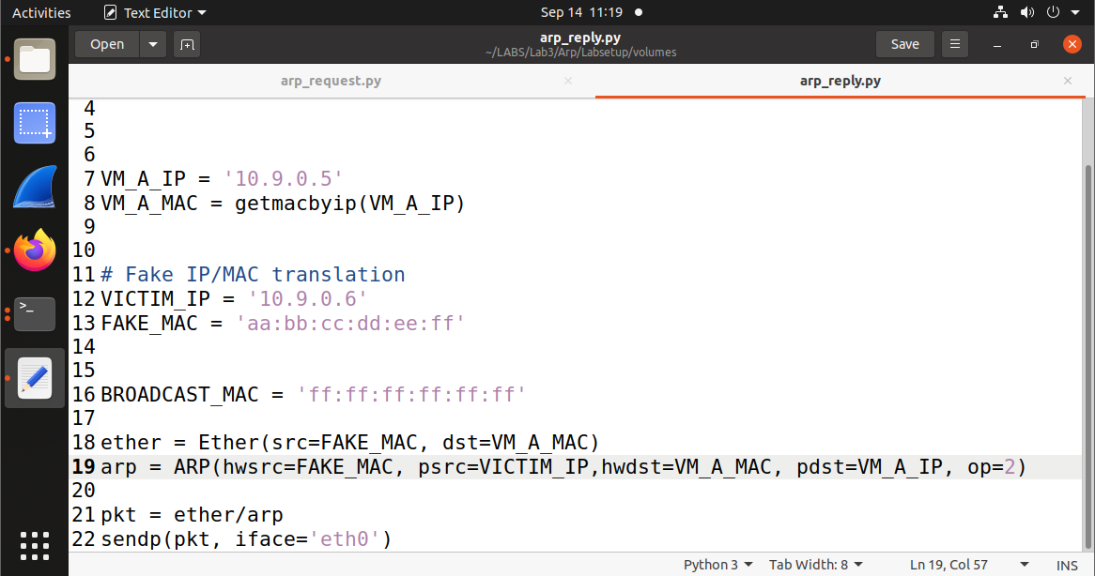

**Running Arp Reply code from attacker**

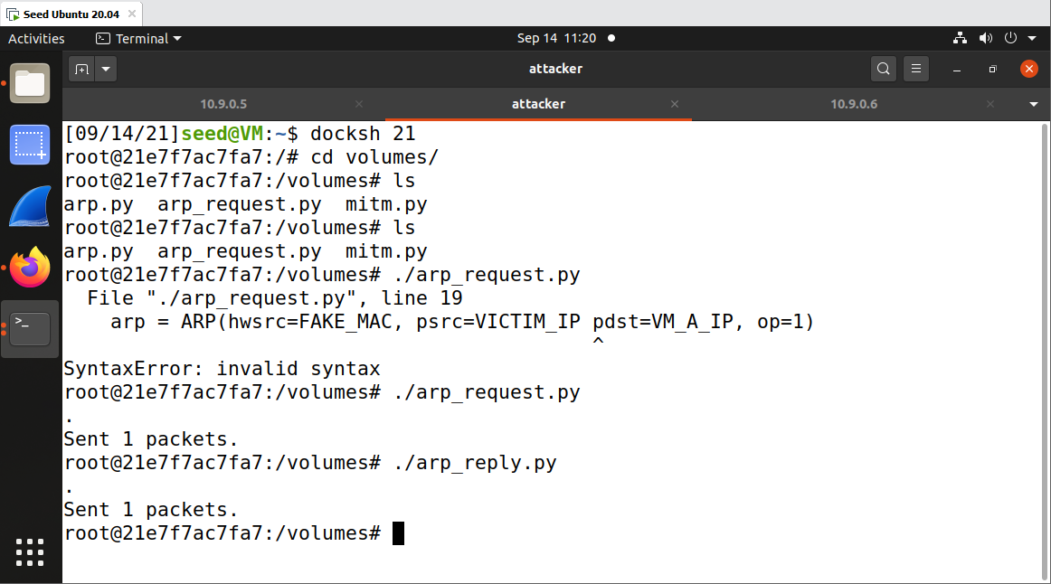

**Code For Gratutious**

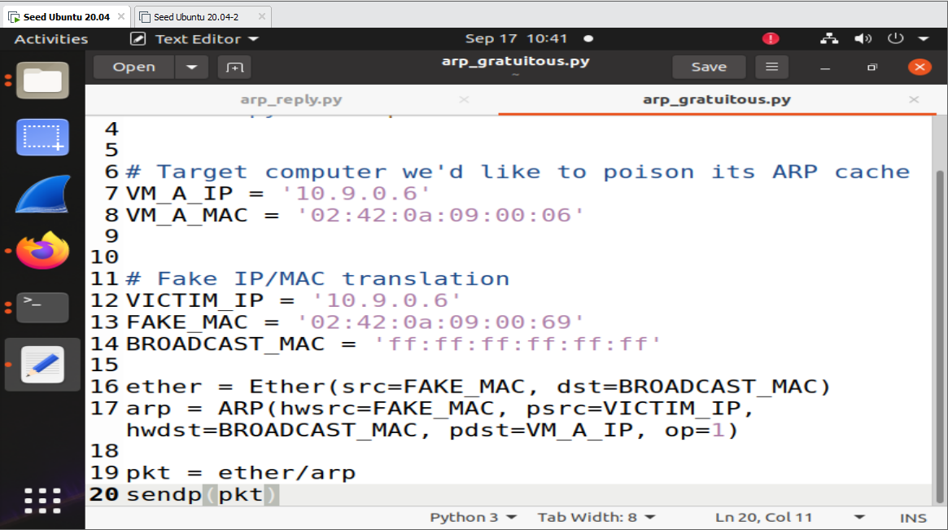

**Sending the gratuitous packet from attacker to 10.9.0.5**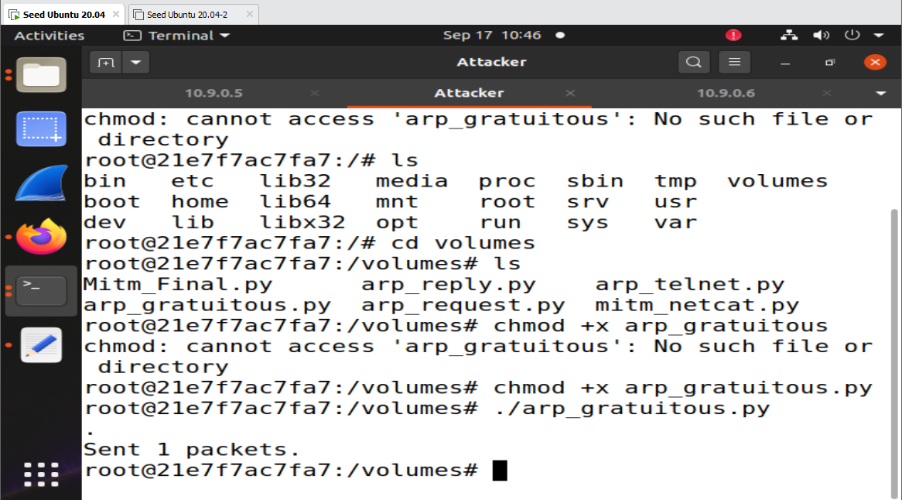

**Ping 10.9.0.6 from victim 10.9.0.5**

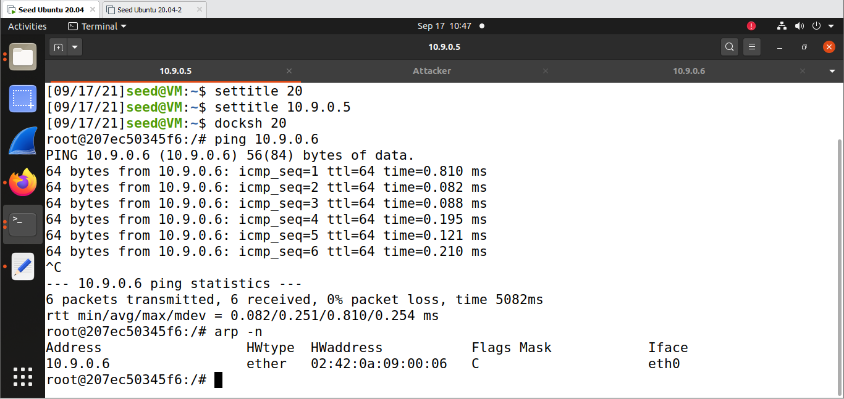

**Forwarding ipv4**

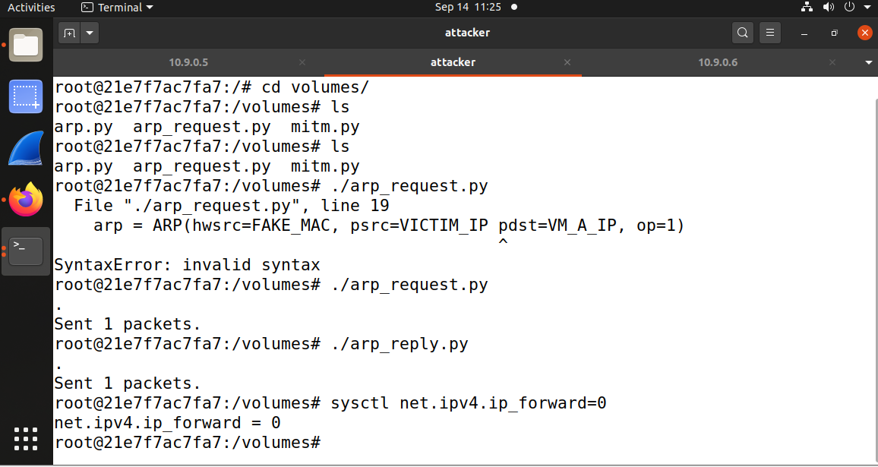

**Listening on port 3333 on docker ip 10.9.0.6**

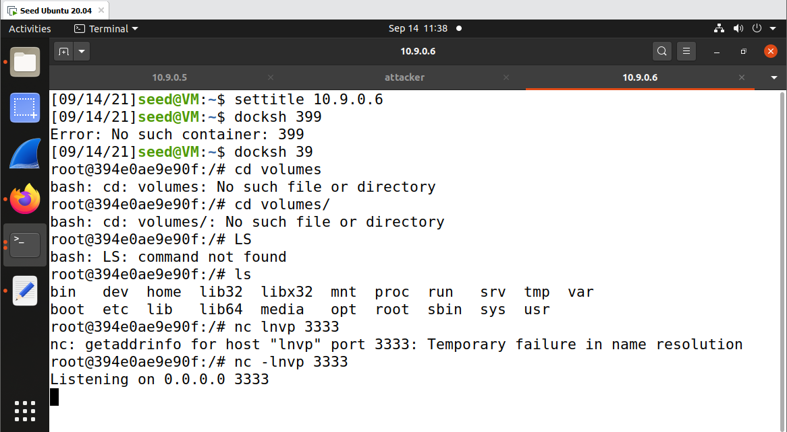

**Creating connection between 10.9.0.5 and 10.9.0.6** 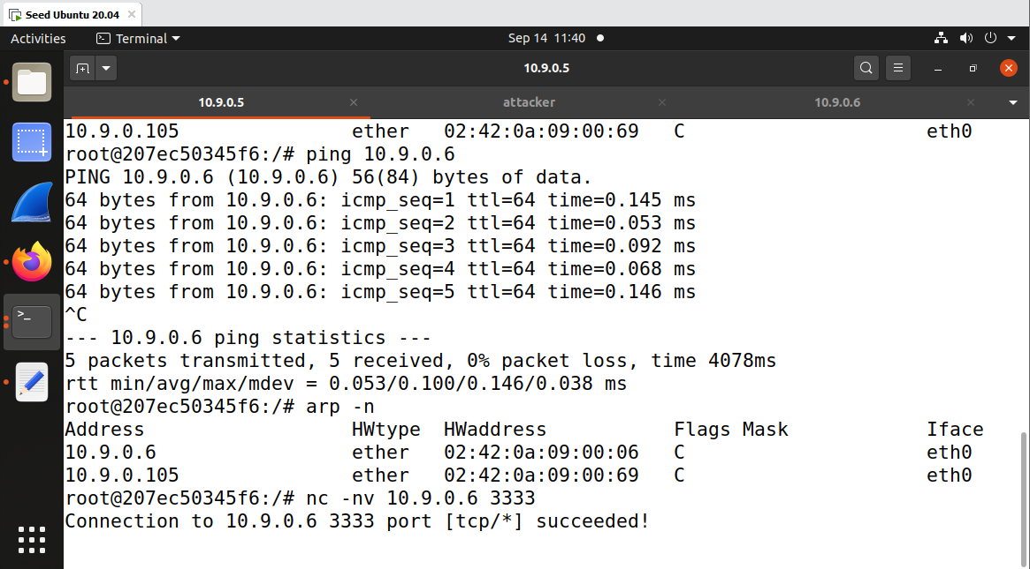

**Receiving the message sent from 10.9.0.5 to 10.9.0.6**

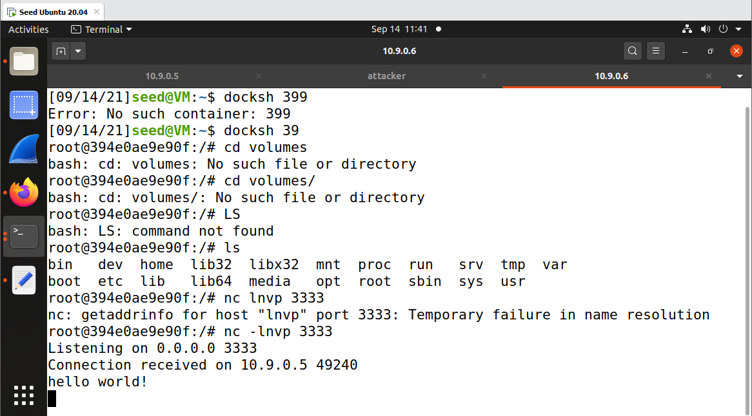

**Code For MITM**

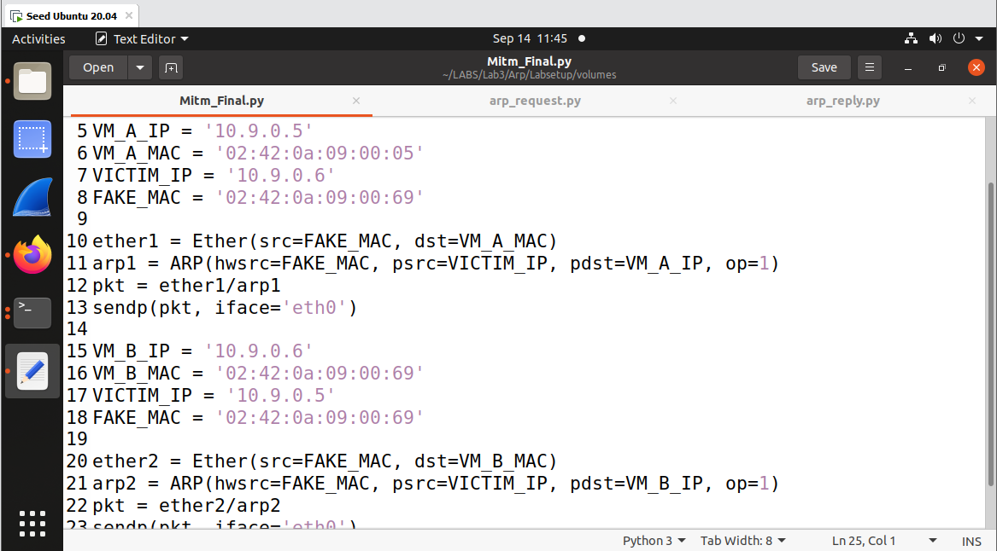

**Running the man in the middle code from attacker**

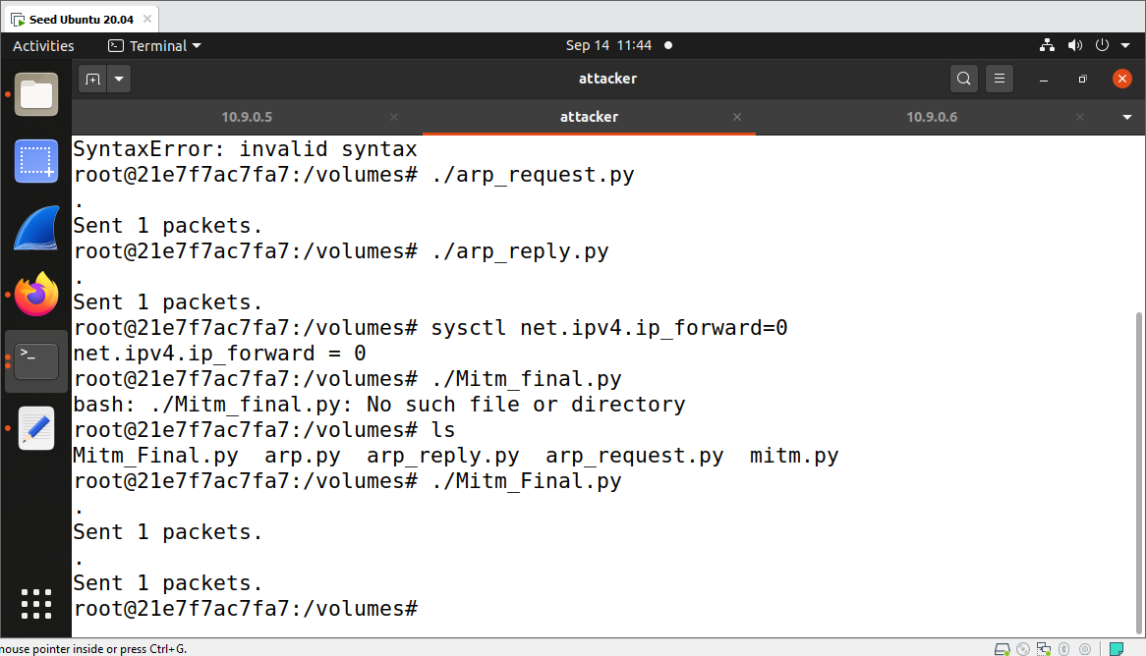

**Tracking the spoofed packets of 10.9.0.5 and 10.9.0.6**

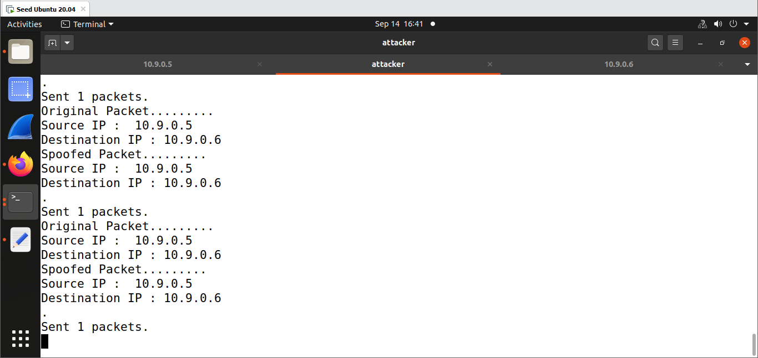

**Sending the messages from 10.9.0.5 to 10.9.0.6**

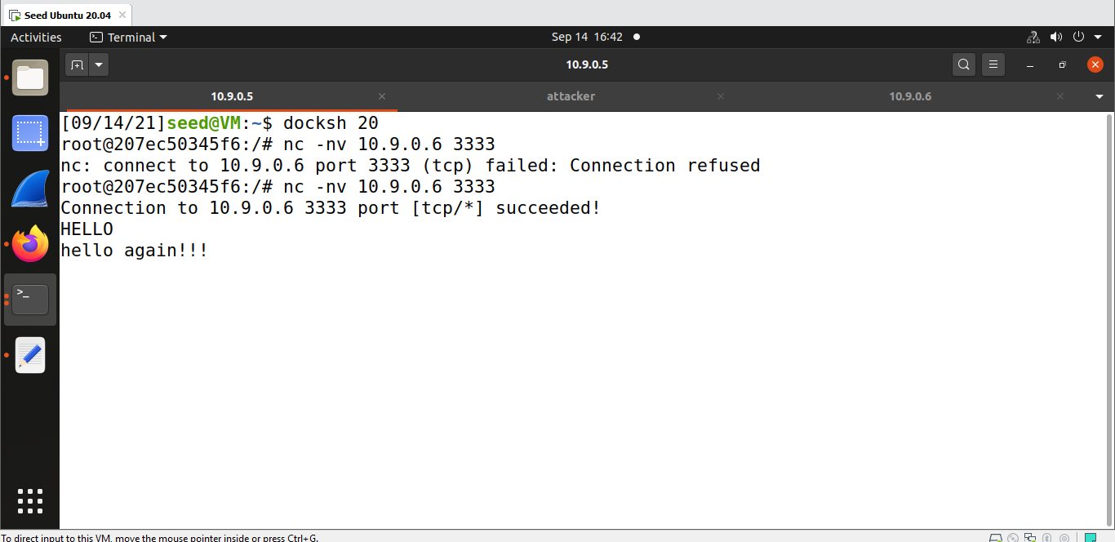

**Successfully spoofed hello from 10.9.0.5 to aaaa in 10.9.0.6** 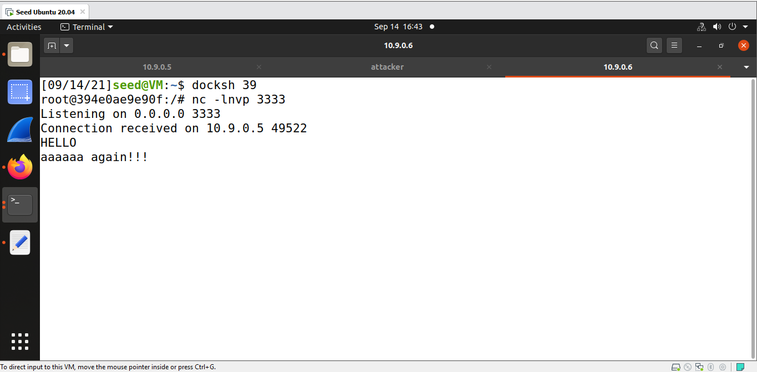

**Telnet 10.9.0.6 and logging into 10.9.0.6**

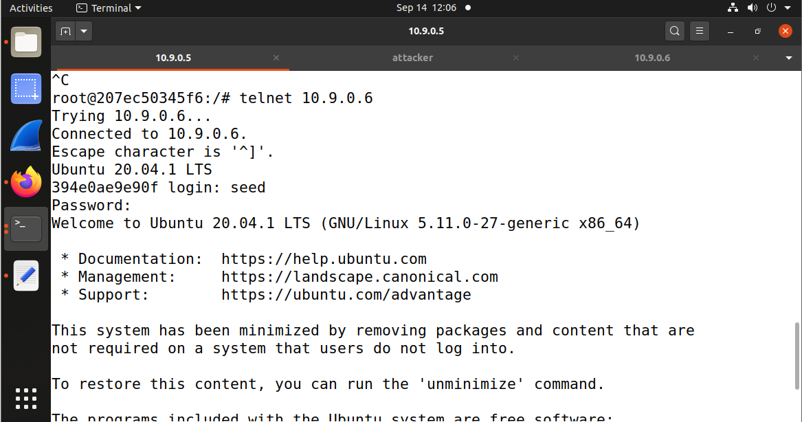

**Code for ARP_TELNET**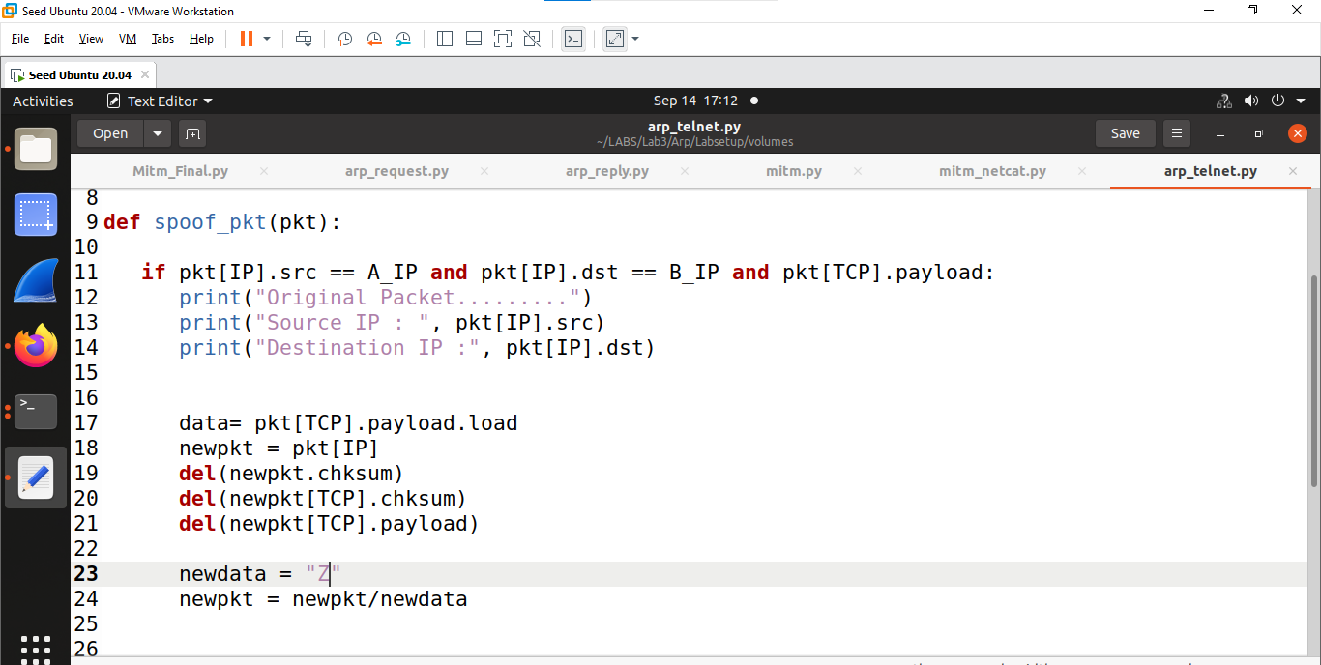

**Checking the code on 10.9.0.5, it is successfully printing only Z even if we are typing other letters**

